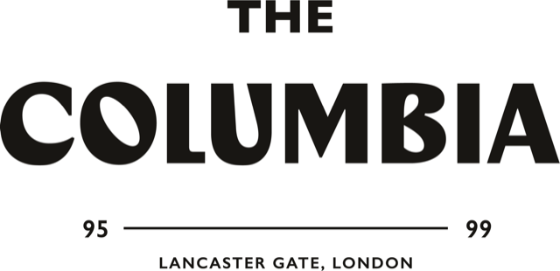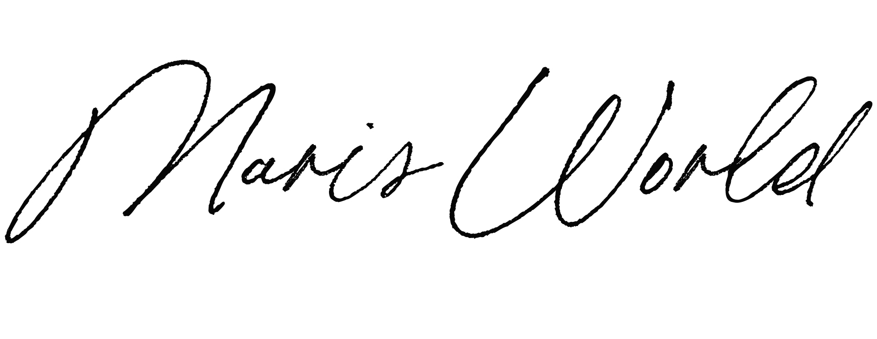

OPEN CALL FOR APPLICATIONS FROM VISUAL ARTISTS AND CREATIVES
FOR A 3-MONTH RESIDENCY

The Columbia and Maris World are pleased to announce the launch of the Winter 2020/21 Residency Programme, offering 3-month residencies for visual artists, creatives, photographers and videographers, starting on 18th January 2021.

The Winter 2020/21 programme is the second in a series of residencies at The Columbia. As part of the opportunity, we will provide shared studio space and other benefits set out below, in exchange for creating works that will be exhibited in the premises. During the programme, residents will have the opportunity to discuss and receive expert guidance on their new projects through group and individual sessions with Marisa Bellani, the founder and principal consultant at Maris World.

The Columbia and Maris World are looking to bring together a diverse group of six highly talented and driven creatives through the residency programme. The overarching theme of this residency focuses on ideas of human connectivity and the permeability and convergence of creative thought. We seek individuals who explore notions of 21st century human relationships and interactions through their processes and/or conceptual research.

The programme will provide a unique opportunity for the artists to expand the parameters of their individual practices, immersing them in a multidisciplinary and stimulating environment whereby new exchanges of ideas and synthesises of different approaches are invited. Our aim is to create a cultural and community-driven space which platforms emerging artistry and fosters ongoing collaboration and cross-pollination of ideas. These are essential factors for our selection process and the residents’ development during the programme. For that reason, we are looking for projects that will contribute to this spirit, while encouraging creatives to develop new ideas and opportunities as part of the programme.

As part of the programme, residents will be able to contribute to a new and unique cultural hub in West London. Through talks and workshops residents will be able to share their experience and knowledge while working towards a final exhibition in The Columbia. The final show will be held in The Columbia’s exhibition space and will showcase the works created during the residency with Maris World.

THE WINTER 2020/21 RESIDENCY PROGRAMME INCLUDES:

- The opportunity to engage with other creatives and create unique collaborative projects.
- The opportunity to develop a project that will be exhibited at the end of the residency alongside the works of the other residents and in a selling show.
- The opportunity to welcome members of the public for studio visits, including curators and other experts in the field (subject to their availability).
- A shared workspace at The Columbia.
- A group follow-up session every couple of weeks and a one-to-one session through the residency with Marisa Bellani.

Residents will leave a piece of creative work for The Columbia’s collection at the end of the residency and will be expected to contribute to the on-going arts programme during their time on the programme.

REQUIREMENTS:

Applicants must be:
- Based in the UK for the duration of the residency and able to travel to The Columbia.
- Working and/or a recent graduate in a creative field (e.g. visual artist, photographer, graphic designer, videographer, etc.).
- Seeking an opportunity to develop a new project or concept.
- Able to explain how this experience will benefit their career.

APPLICATION PROCESS:

Applicants are required to submit their completed applications by Sunday 27th December 2020. Results will be announced the week commencing 11th January 2021.
Applicants must include a biography, CV and a portfolio of their work, as specified below.

Please submit the following documents:

- Completed Application Form
> See Application Form below

- A pdf presentation, including:
- 10 x images of works or 2 x samples of writing or 2 x video works
- 5 x exhibition views (if applicable)
- A biography (max. 150 words) and CV
- An artist’s statement (max. 250 words)

- Relevant website links
Referencing your achievements or any press features. Please list any awards, book publications or notable achievements.
HOW TO SUBMIT YOUR APPLICATION:

- Submit your application electronically to residency@thecolumbia.co.uk
- Subject line of your email: The Columbia Residency Programme – Winter 2020/21
- Please send all attachments in one email (total size max. 10 MB)
- Do not include more documents than the ones requested
- We will only review the attached documents, and only if they contain a portfolio of images.

ABOUT THE COLUMBIA

The Columbia is an independent hotel and event space in the heart of West London. Set across five Victorian townhouses built in 1856, the hotel has a rich and spirited history, with many well-known music icons passing through its doors in the 80s to early 00s. The Columbia offers a range of private studios, work and exhibition spaces where artists can create and showcase their work within a non-traditional arts space. The ongoing music and arts programme at The Columbia aims to platform emerging artistry, whilst building an inclusive and diverse creative community.

ABOUT MARIS WORLD

Maris World was born out of the desire of its founder, Marisa Bellani, to create a platform where artists and creatives could discuss and build their confidence, and seek help in finding their voice in order to better channel and orient their practices. Through the applications of positive thinking, brain-based psychology and human counselling techniques, we place artists and creatives into their future zone in order to align their work to themselves or their desired objectives. We seek to embed long-term strategic thinking and to give them the tools to operate those changes independently so that they can continue to develop their careers. Maris World aims to be a gathering forum from where our members can expand their horizons and receive support through individual counselling, as well as through webinars/conferences and from other members of our community.

ABOUT MARISA BELLANI

Marisa Bellani is the founder and principal consultant at Maris World. She is also the founder and creative director of Roman Road, a space for collaborative exhibitions in London. Marisa has been running Roman Road since 2013, following and fostering notable projects and working with artists from all over the world. With her substantial experience and expertise in the gallery system and contemporary art scene, she is a valued influencer in the field and has dedicated her career to bolstering the talents of emerging and mid-career artists. Marisa has completed two master degree courses, firstly at the Institut d’Études Supérieures des Arts and subsequently at Sotheby’s Institute of Art. She has held a seat and became the youngest member of one of the Tate’s Acquisition Committees and regularly participates in panel discussions and portfolio reviews, and gives talks at art universities.

WINTER 2020/21 RESIDENCY APPLICATION FORM

About you

First name:
Last name:
DOB:
Place of birth:
Gender
(e.g. female/male/non-binary/transgender/prefer not to say:
Nationality:
Current address:
Telephone number:
Mobile number:
Skype ID:
Email address:
Website address:
Instagram handle:
Current status (working / graduate and where):

About your work

How would you describe your practice and its correlation with the theme of the Winter 2020/21 Residency in 250 words?

Please explain how you see your practice evolving in the next couple of years:

Your motivation

How do you think you can contribute to The Columbia and what will The Columbia Residency bring to your practice?

Links to works

As an alternative to submitting a pdf portfolio, you can send us link to your works. Please list any relevant links below:

