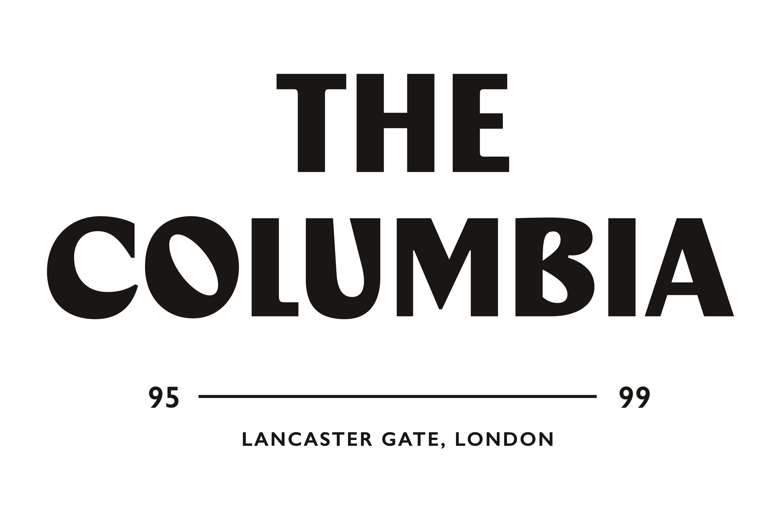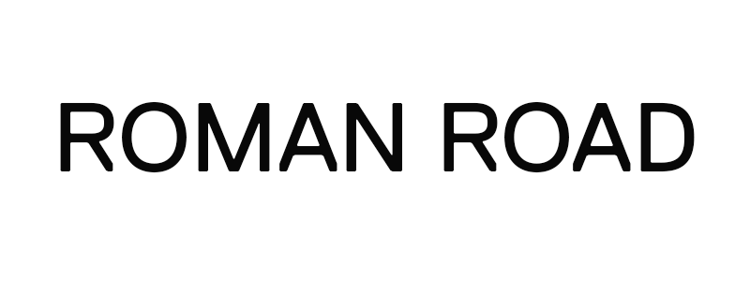

OPEN CALL FOR APPLICATIONS FROM UK-BASED ARTISTS, CREATIVES, AND WRITERS FOR A SIX-WEEK RESIDENCY

In partnership with Roman Road, The Columbia is launching The Columbia Residency Programme, offering six-week residencies for UK-based artists, creatives, photographers, videographers and writers in summer 2020, starting on 3rd August.

The summer programme will be the first of a series of residencies that aim to create a synergy between creatives and The Columbia. As part of the opportunity, we will provide shared studio space, a budget for materials and other benefits set out below, in exchange for creating works that will be exhibited in the premises.

The Columbia and Roman Road are looking to bring together a diverse group of highly talented and driven creatives through the residency programme. The programme will provide a unique opportunity for the artists to expand the parameters of their individual practices, immersing them in a multidisciplinary and stimulating environment whereby new exchanges of ideas and synthesises of different approaches are invited. Our purpose is to create a cultural and community-driven hub where collaboration and cross-pollination of ideas is supported. These are essential factors for our selection process and the residents’ development during the programme. For that reason, we are looking for projects that will contribute to the spirit of The Columbia, while encouraging creatives to develop new ideas and opportunities as part of the programme.

The residents will help to shape a new and unique cultural hub in West London. They will contribute to the public programme of events through talks and workshops sharing their experience and knowledge. They will also work towards a final exhibition in The Columbia exhibition space, showcasing the works they have created during the residency.

In light of the COVID-19 pandemic, The Columbia has developed measures to adhere to social distancing guidelines and to ensure residents are able to work in a safe and responsible manner.

THE COLUMBIA RESIDENCY PROGRAMME INCLUDES:

- The opportunity to engage with other creatives and create unique collaborative projects
- The opportunity to develop a project that will be exhibited at the end of the residency alongside the works of the other residents and in a selling show
- The opportunity to welcome members of the public for studio visits, including curators and other experts in the field (subject to their availability)
- A budget of up to £350 for materials
- A shared workspace at The Columbia
- A weekly group follow-up session and a one-to-one check-up midway through the residency with an expert in the field.

Residents will leave a piece of creative work for The Columbia’s collection at the end of the residency and will be expected to contribute to the on-going arts and events programme during their time at The Columbia.

REQUIREMENTS:

Applicants must be:
- Based in the UK for the duration of the residency and able to travel to The Columbia
- Working or studying in a creative field (e.g. visual artist, photographer, writer, graphic designer, videographer, etc.)
- Seeking an opportunity to develop a new project or concept and founding a brand-new residency
- Able to explain how this experience will benefit their career.

APPLICATION PROCESS:

Applicants are required to submit their completed applications by 21st July 2020. Results will be announced on 24th July 2020.
Applicants must include a biography, CV and a portfolio of their work, as specified below.

Please submit the following documents:

- Completed Application Form
> See Application Form below

- A pdf presentation
Including:
- 10 x images of works or 2 x samples of writing or 2 x video works
- 5 x exhibition views (if applicable)
- A biography (max. 150 words) and CV
- An artist’s statement (max. 250 words)

- Relevant website links
Referencing your achievements or any press features. Please list any awards, book publications or notable achievements.

HOW TO SUBMIT YOUR APPLICATION:

- Submit your application electronically to residency@thecolumbia.co.uk
- Subject line of your email: The Columbia Residency Programme – Summer 2020
- Please send all attachments in one email (total size max. 10 MB)
- Do not include more documents than the ones requested
- We will only review the attached documents, and only if they contain a portfolio of images.

ABOUT THE COLUMBIA

The Columbia is a proudly independent, family-owned hotel, overlooking Kensington Gardens. Built in 1856, the building is made up of five Grade 2 listed Victorian townhouses and is full of character and charm. The Columbia has a rich history, with many well-known music icons passing through its doors in the 80s to early 2000s. After closing to the public in March due to the COVID-19 pandemic, The Columbia has taken this time to convert its ground and first floor spaces and looks forward to re-opening in mid-August as a hotel, creative house and event space. This unique space in the heart of West London will provide creatives from all disciplines with the opportunity to create, collaborate and showcase their talent.

ABOUT ROMAN ROAD

Roman Road, founded by Marisa Bellani in 2013, grew organically from a project space to a gallery through establishing itself as a space of reference for contemporary art and photography. Located in London, Roman Road has recently redefined itself with a more fluid and cooperative approach, becoming a platform for collaborative exhibitions since the end of 2019. In 2017 Roman Road also added a research cell and an online journal to its activities in order to expand its horizons and to share with its audience information and knowledge that would go beyond art. The gallery has established a qualitative programme of around ten shows annually, including participations at notable international art fairs. Over the years, Roman Road has represented a talented roster of artists, among which Antony Cairns and Alix Marie, who have also seen their works exhibited in such institutions as Tate Modern, Stedelijk Museum and Musée des beaux-arts Le Locle. Since its marked shift to a collaborative platform, Roman Road supports young artists in expanding their careers and further learning to put together an exhibition and take the opportunity to push their practice further.

SUMMER 2020 RESIDENCY APPLICATION FORM

About you

First name:
Last name:
DOB:
Place of birth:
Gender
(e.g. female/male/non-binary/transgender/prefer not to say:
Nationality:
Current address:
Telephone number:
Mobile number:
Skype ID:
Email address:
Website address:
Instagram handle:
Current status (working / student and where):

About your work

How would you describe your practice in 250 words?

Please explain how you see your practice evolving in the next couple of years (max. 250 words):

Your motivation

How do you think you can contribute to The Columbia and what will The Columbia Residency bring to your practice?

Links to works

As an alternative to submitting a pdf portfolio, you can send us link to your works. Please list any relevant links below:

